User Documentation
Sarah Grenot RT211

This documentation is for helping people to better understand the graphic interfaces

What is working ?
-connecting a server(localhost,10065)
-sending predefined and easy command
-showing the results of the command
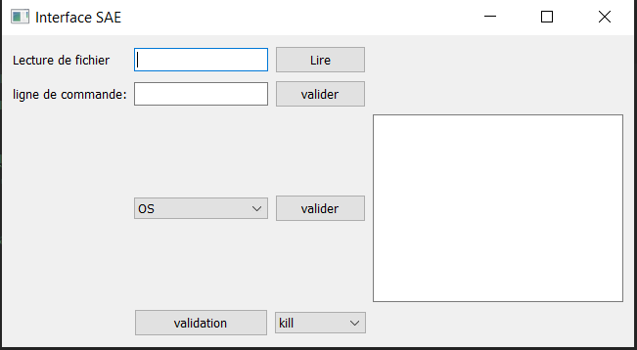
-sending kill,disconnect,reset

First step :
To use the interfaces you will need to have a server that is waiting to receive a connection, to connect to the server from the interfaces

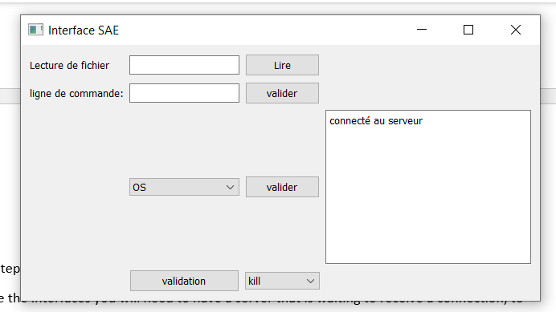
You will need to click “lire” when the connection is set you will have a confirmation messages onr the blank box.
Then you can start asking the server information

The server informations

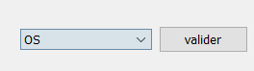
This box contain all the commands that can be send and then print on the blank box
You just need to select which information you would like to know and the click on “valider”

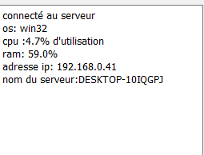
They are all the option that can be send back to you within the different possibilities

Kill,reset disconnect

Those are working the same as the information gathering .We have a small list with three options :
Kill that will shut down the server AND the client message that the server is killed
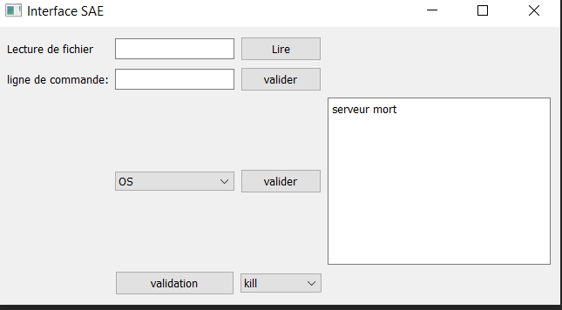

Disconnect it will disconnect the client from the server a message will appear that you are disconnected.
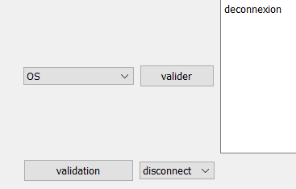

Reset we start back a new connection in a new socket(interface can disconnect but not reconnect to the new socket need to be done by yourself)
